|  |
| --- |
| Trinity College University of Dublin |
| CS4001 Report |
| Group project, in collaboration with: Sebastian Ruder & Aran Sena |

|  |
| --- |
| Fabian Miiro  1-8-2015 |

Contents

Introduction 1

Background 1

Sleep 1

Usage of fuzzy logic 1

TSK vs. Mamdani 1

Simulation / Model 2

Inputs (DESCRIBE THEM) 2

Last meal or drink 2

Slept day before 2

Exercise during day 2

First meeting 2

Time went to bed 2

Current sleep cycle 2

Time to sleep 2

Quality 2

Rules 4

Defuzzification methods 4

Outputs 4

Results & Analysis 5

Results 5

Screenshots 5

Example runs (tables + sentences) 7

Evaluation 7

Conclusions 8

Rules 8

References 9

Expectations 10

Fuzzy Wakeup System

# Introduction

As a part of the course Fuzzy Logic & Control Systems we have created a control system that uses fuzzy logic. This control system is based upon the notion of an alarm but has also been thought about to be extended to a fully featured “wakeup system”. The difference is that the wakeup system helps you all the way until you’re fully awake. This could include things as the amount of coffee you get, the length of the shower and so on.

We did it because the idea was interesting enough and something where we thought we could incorporate what we had learned.

The Fuzzy system we created outputs favourable results that we think gives us a certain degree of confidence that it was worth using fuzzy logic. It was definitely worth using fuzzy logic because of the learning process, and the fuzzy nature of sleep and the human day and night cycle.

# Background

## Sleep

Sleep is something we all do, we all need to do it, but we really don’t know why we do it. A perfect subject for a fuzzy system ☺

Our sleep is affected by numerous of things. Most of these are highly individual, such as how much we need to sleep or how much movement every day is normal. While some are a little bit more universal, this could be that we should eat at least three hours before bedtime.

The concept behind this system is that it should be used in a ‘connected’ home. This wakeup system would be integrated with the rest of the house and be able to talk to for example the coffee machine, lights, and the car to make sure everything works to make the mornings as pleasant as possible.

## Usage of fuzzy logic

This problem is a good match for a fuzzy system because of the fuzzy nature of the problem (as described in previous chapter). There are no crisp values that can be used on such a personal system and every day is different from a systems point of view.

### TSK vs. Mamdani

We have chosen to use the Mamdani system for a couple of reasons. Firstly it’s the first system we got to play with and go through during lectures so also the one we feel most comfortable with. But the strong point for TSK and why it’s mainly used is it’s mathematical simplicity which makes it extremely fast. Since our system is designed to work while you sleep (and will therefore have several hours for computation) this isn’t really a problem we need to solve. TSK is excellent for real-time systems. But for us, the way we model the system and the preciseness is more important.

Why fuzzy logic is a good choice.

# Simulation / Model

## Inputs (DESCRIBE THEM)

### Last meal or drink

The input value is the number of minutes since the last meal or drink was consumed. The membership function is based on data from Joy Bauer’s article “How Food Affects Your Sleep”[1]

### Slept day before

The number of minutes that the ‘user’ slept the previous day. This data could possibly be from the systems logs of previous days, user input or some activity tracker. This membership function is based upon the group members own views of how much sleep is necessary for the different levels.

### Exercise during day

How many calories were burnt during the day. (data from wearables). The membership function here is based upon the article

### First meeting

At what time is the first appointment the upcoming day?

### Time went to bed

At what time did the ‘user’ went to bed?

### Current sleep cycle

In which sleep cycle is the user currently?

### Time to sleep

In minutes, how long time there is available to sleep

### Quality

What is the quality of the sleep? (calculated by an external system)

## Rules

## Defuzzification methods

## Outputs

The outputs are from the categories

* Easiness of falling asleep
* Time to sleep
* Quality
* Time of alarm
* Easiness of waking up

# Results & Analysis

## Results

### Screenshots

#### Easiness of falling asleep

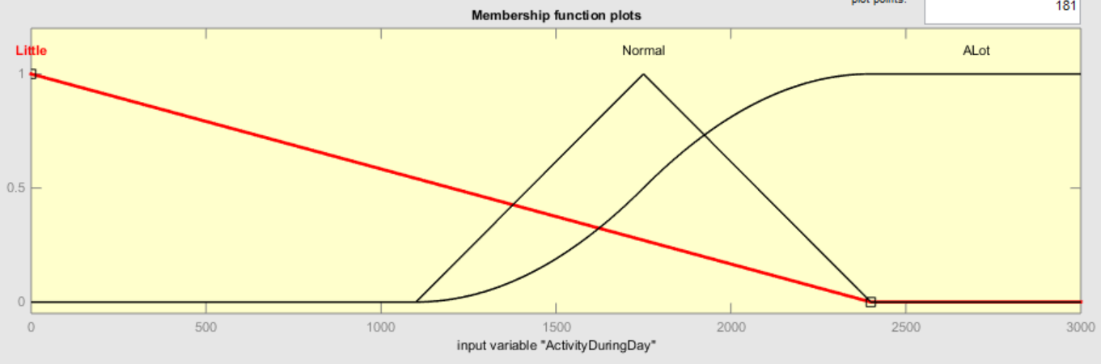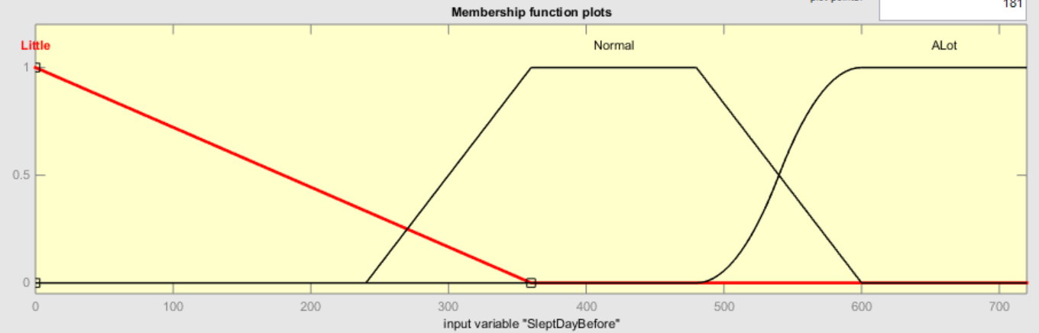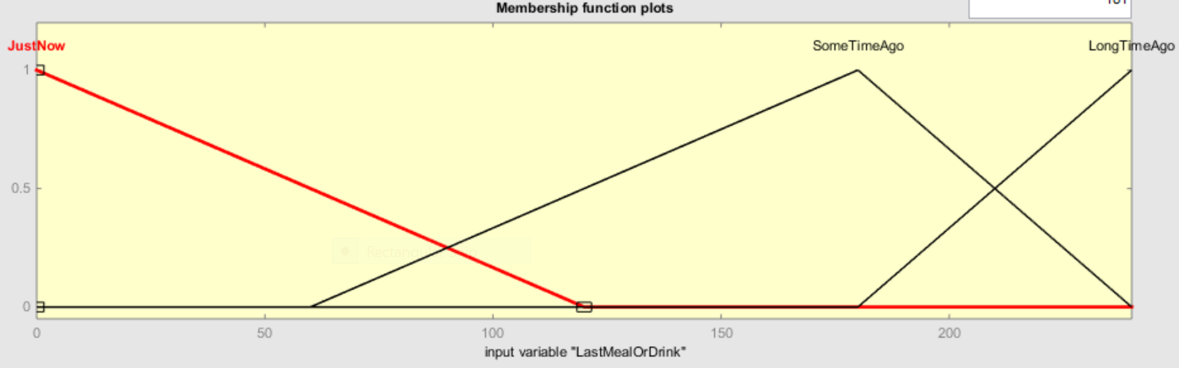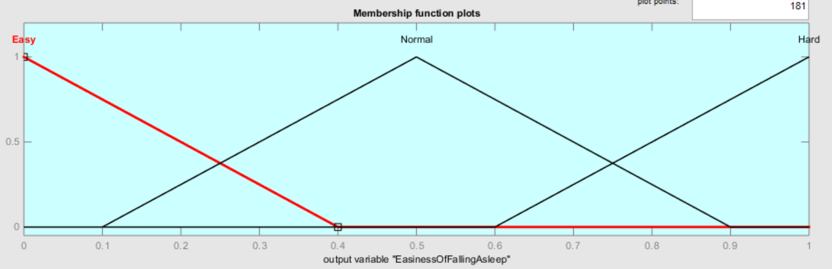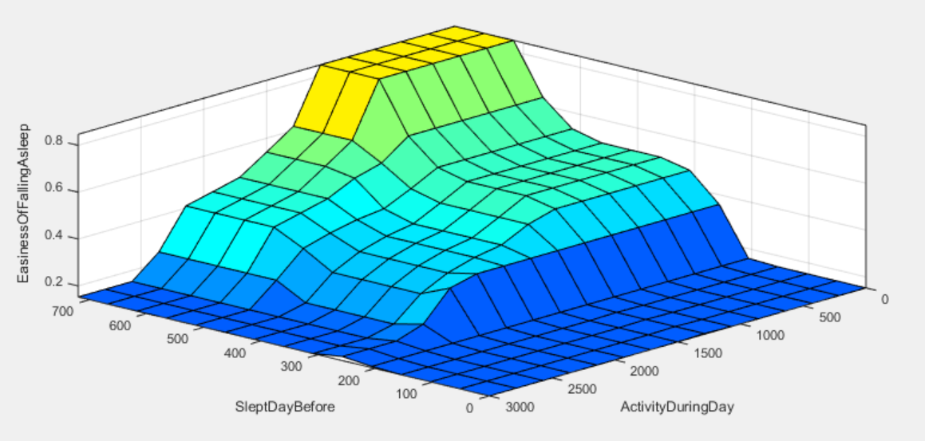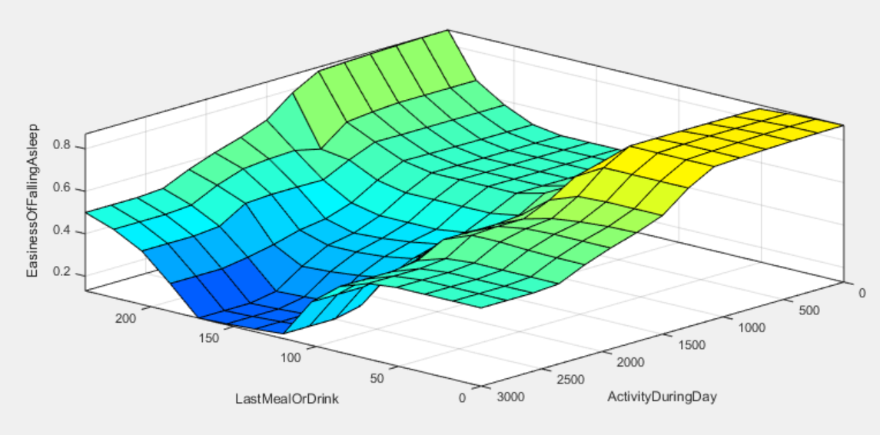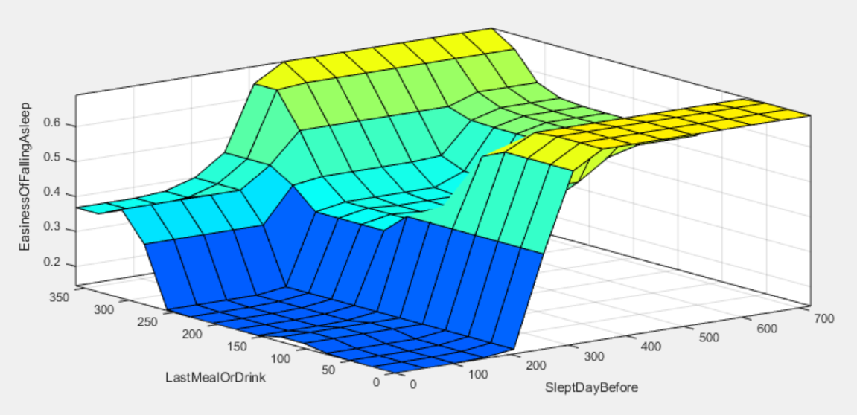

#### Easiness of waking up

### Example runs (tables + sentences)

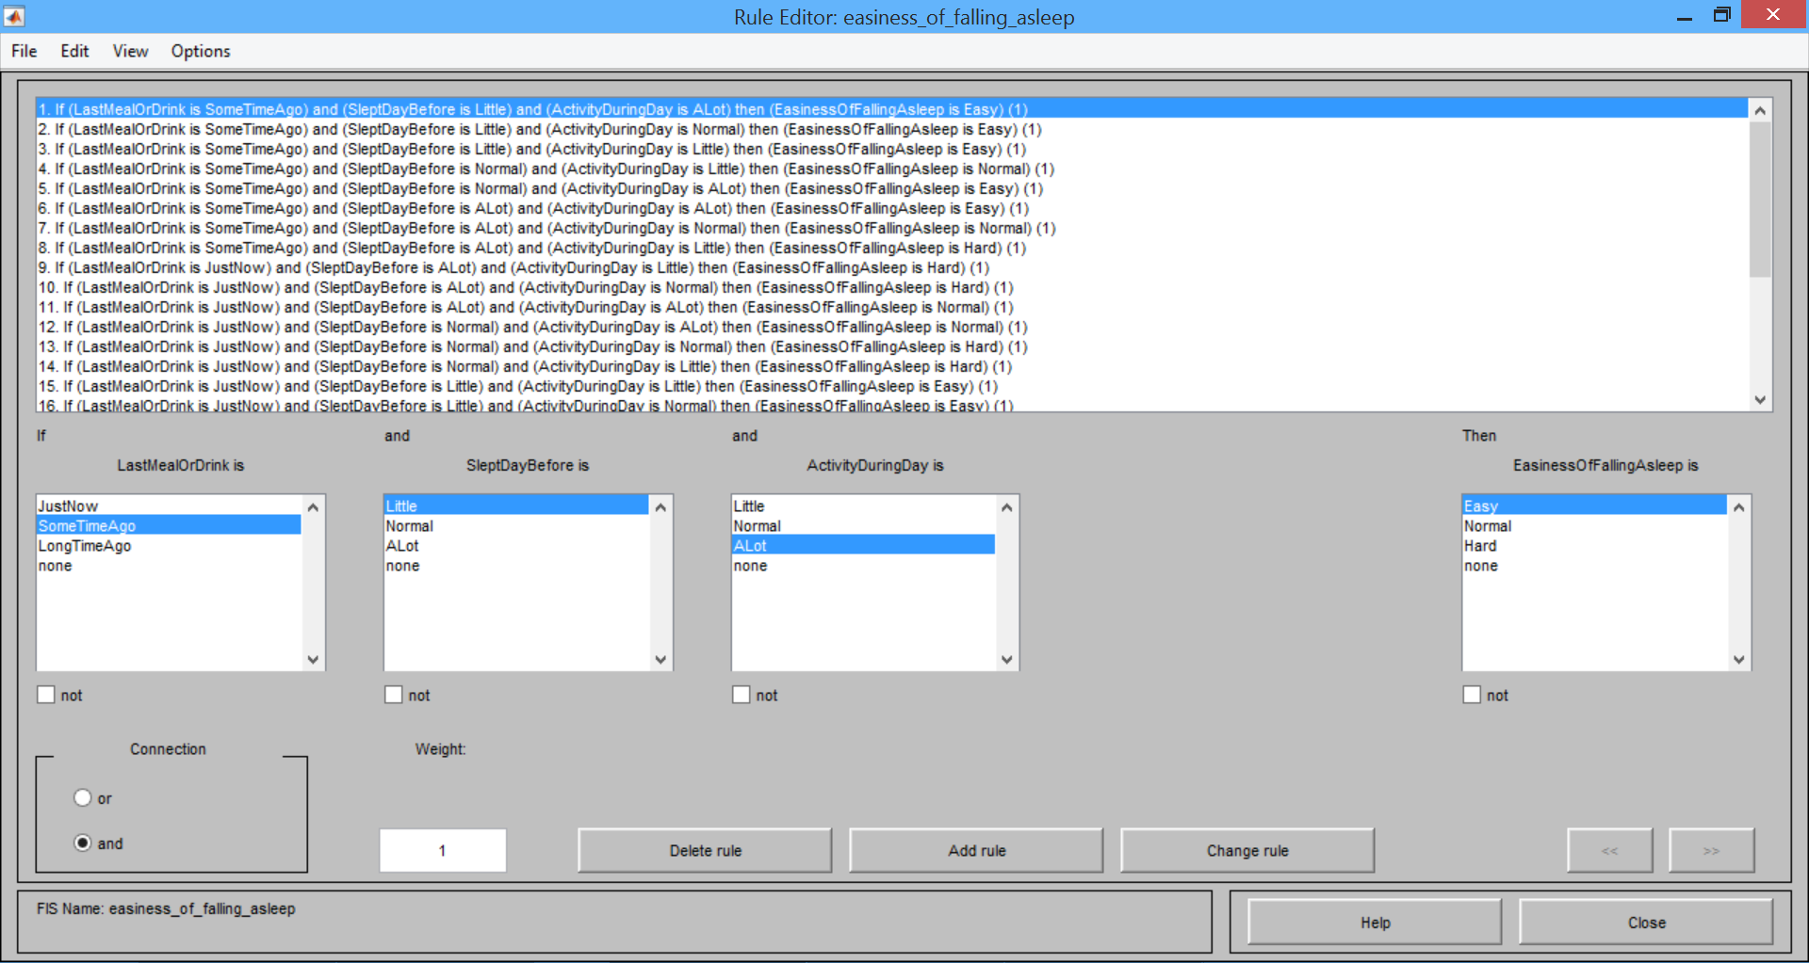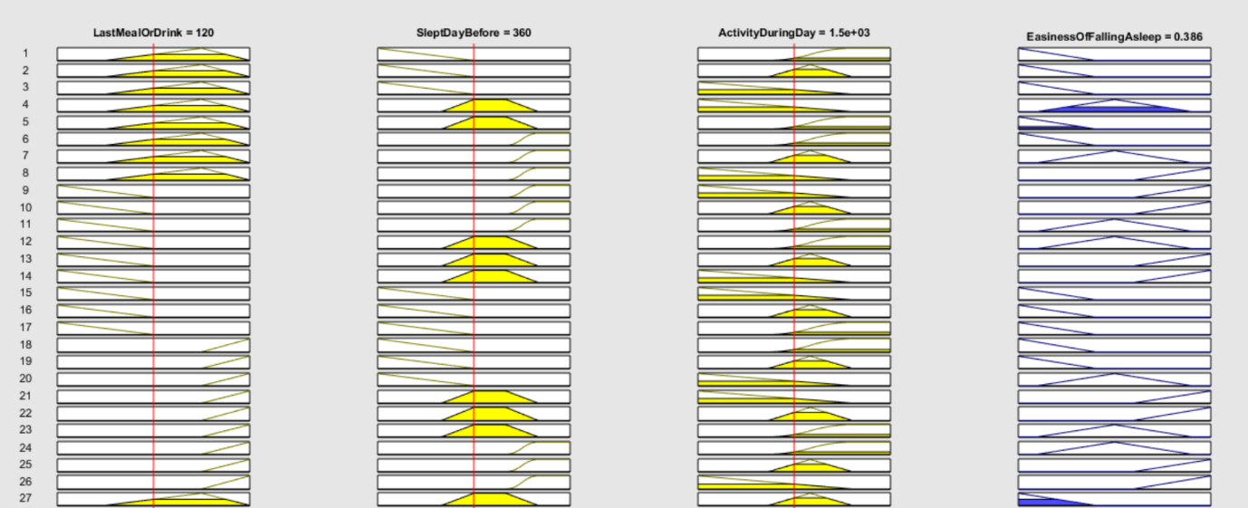

## Evaluation

[How are the results?]

The results are actually surprisingly good. Provided input data and examining the output will in most cases provide a reasonable wakeup time. However we’ve had to jump through some loops to make it all work, distort some amplifiers to make it work more as the real world. Something that would have been a better solution would have been to instead of having the commute time as input just subtract the commute time from the output time. Since the commute time isn’t generally fuzzy but a crisp value based on how long it takes for the bus/car to get to the meeting. (you could argue it’s fuzzy because a ‘long’ commute can be different things for different people but still be different time, but I’m not going to get into that discussion right now [maybe do get into the discussion?])

[Justify our choices]

Since our output “easiness of falling asleep” is an amplifier being used as a percentage value we have a very clear and consistent output membership curve. Some other data might also need a bit of an explanation.

We decided to use the value “time to sleep” instead of “time of alarm” after several discussion about the advantages with the two different kinds of values. We settled with time to sleep because it’s more easy work with and doesn’t require any extra steps to figure out if that’s a long nights sleep or not.

# Conclusions

Was a fuzzy solution justifiable?

Yes, a fuzzy solution was in this case definitely justifiable because of the fuzzy nature of the problem. A crisp system would have problems with different people and would therefore most probably be designed for a “normal” person. Since our system is fuzzy it will still be able to handle people that are outside the normal bounds in let’s say sleep pattern or calories burnt per day.

# Rules

The rules are categorized based upon output

* Time to sleep is calculated based upon these inputs:
  + First meeting
  + Last meal or drink
  + Went to sleep
  + Slept day before
  + Current sleep cycle
* Here are some rules I came up with
  + IF First meeting IS VERY EARLY AND Went to sleep IS VERY LATE Time to sleep IS VERY LITTLE
  + IF First meeting IS VERY EARLY AND Went to sleep IS LATE Time to sleep IS VERY LITTLE
  + IF First meeting IS EARLY AND Went to sleep IS VERY LATE Time to sleep IS VERY LITTLE
  + IF First meeting IS EARLY AND Went to sleep IS LATE Time to sleep IS LITTLE
  + IF First meeting IS NORMAL AND Went to sleep IS LATE Time to sleep IS LITTLE
  + IF First meeting IS NORMAL AND Went to sleep IS NORMAL Time to sleep IS ENOUGH
  + IF First meeting IS NORMAL AND Went to sleep IS EARLY Time to sleep IS ENOUGH
  + IF Went to sleep IS EARLY AND Current sleep cycle IS DEEPLY ASLEEP Time to sleep IS LONGER THAN USUAL
  + IF Slept day before IS VERY LITTLE AND First meeting IS VERY LATE Time to sleep is LONGER THAN USUAL
  + IF Slept day before IS LITTLE AND First meeting IS LATE Time to sleep is LONGER THAN USUAL

# References

<http://sleepfoundation.org/how-sleep-works/how-much-sleep-do-we-really-need/>

<http://www.joybauer.com/insomnia/how-food-affects-sleep.aspx> - Summary: eat at least three hours before bedtime. Eating just before might keep you awake

<http://www.webmd.com/sleep-disorders/features/cant-sleep-adjust-the-temperature> - Summary: You should have the room a little bit colder when you sleep. But at a comfortable level ☺

<http://www.thedietchannel.com/AskTheExpert/dieting-weightloss-obesity/Calories-Whats-an-ideal-daily-intake.htm> - Summary: We should eat 3 meals and 2-3 snacks per day. 400-600 calories per meal for men, 300-500 for woman and 100-200 calories per snack. This makes the “normal” span between 1100 to 2400

## Expectations

* Proper English (Grammar, punctiotion, full sentences)
* Reasonable amount of references, 3 to 5 preferred.
  + Both fuzzy logic and domain specific references.
  + Peer-reviewed (i.e. avoid wikipedia / anonymous webpages)
* Don't plagiarize
* Results, screenshots, rules, etc… will be the same for everyone in a group.
* The simulation submission is to verify you did what you're reporting to have done.
* The best and worst group may be investigated.
* The coursework is marked individually, but good group-work helps.
* Avoid over-complication the problem: Fuzzy logic is deployed to simplify solutions, not the other way around.

1. <http://www.joybauer.com/insomnia/how-food-affects-sleep.aspx>